PROJECT

FLOW 👍

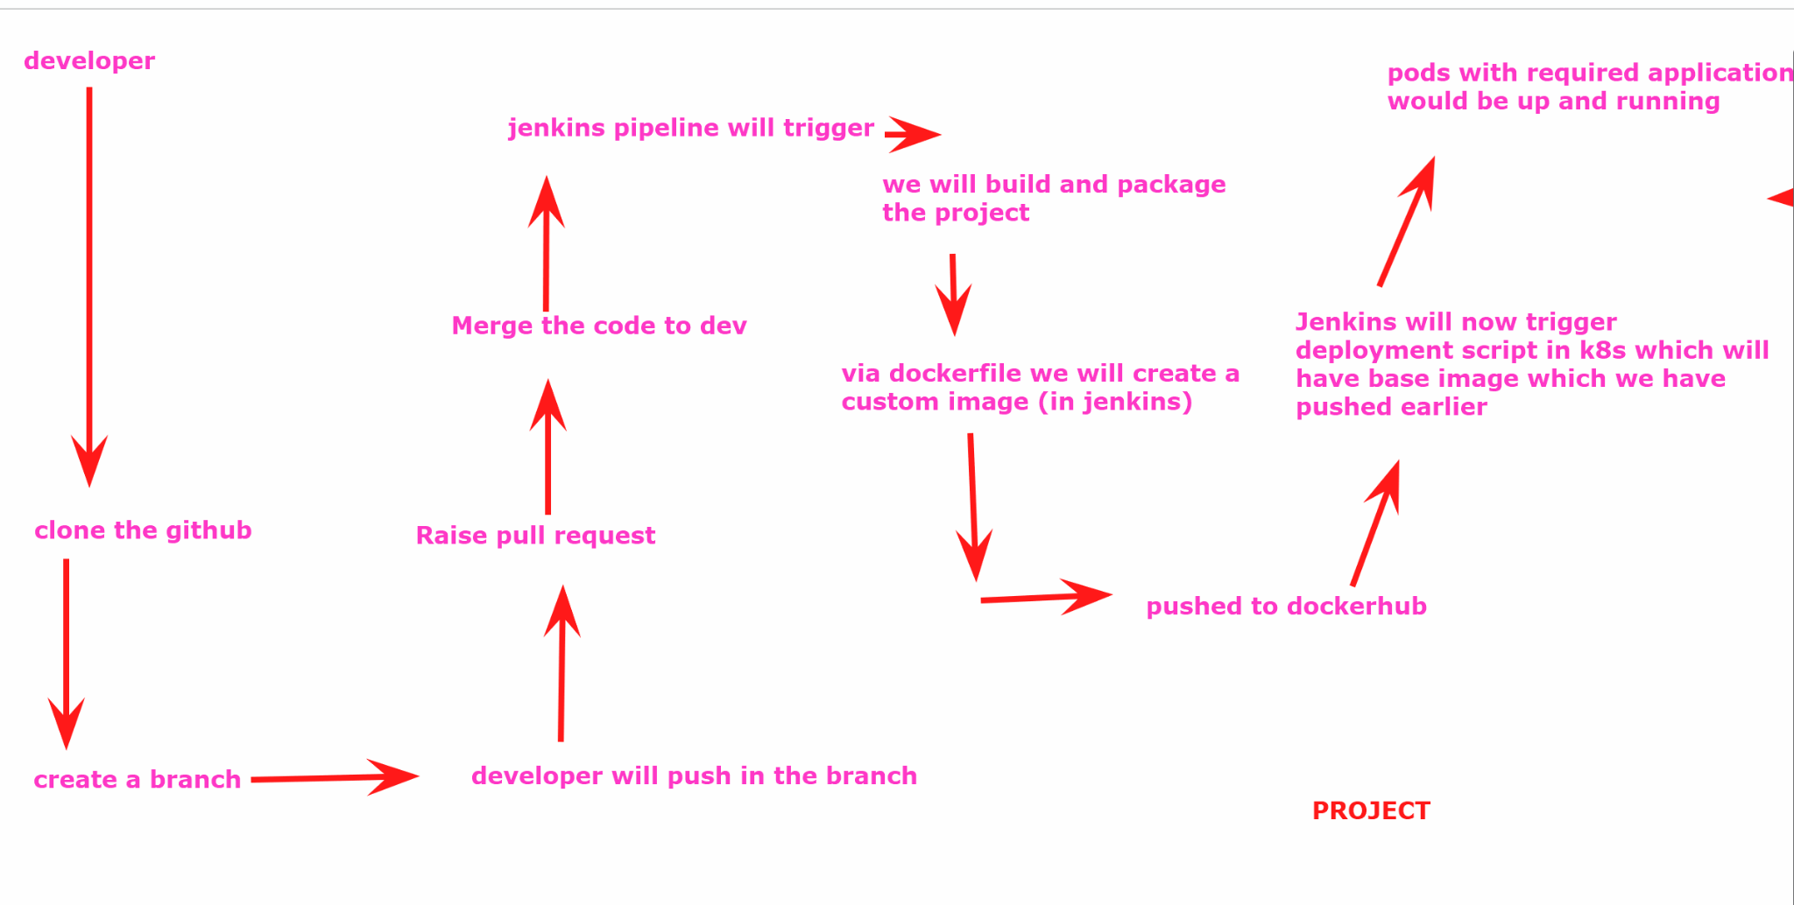

We will launch 3 aws ubuntu machines - t3.medium with all traffic enabled in the security group and use ebs as 20 gb storage

1st machine : jenkins , docker , k8s (master machine)

2nd and 3rd machines: k8s nodes

Use this document to install kubernetes <https://github.com/akshu20791/Deployment-script/blob/main/readme-k8s>

We will install jenkins in the master machine as well:

wget https://raw.githubusercontent.com/akshu20791/Deployment-script/main/jenkins.sh

ls

chmod +x jenkins.sh

./jenkins.sh

### NOW WILL GO TO THE PROJECT REPO : <https://github.com/akshu20791/cicdakshat/>

Fork the project

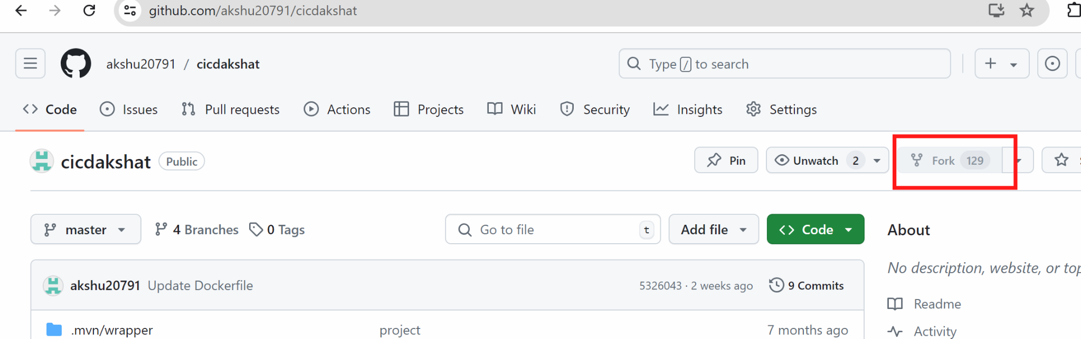

After this you can use the repo by yourself and make the changes as well

Create a new folder

Open git bash

And clone the repo

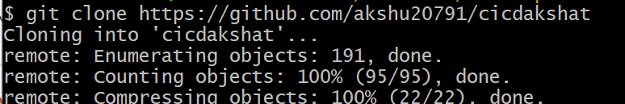

# cd cicdakshat

# gir branch devops1

# git checkout devops1

Create a file …..start tracking thee file …commit

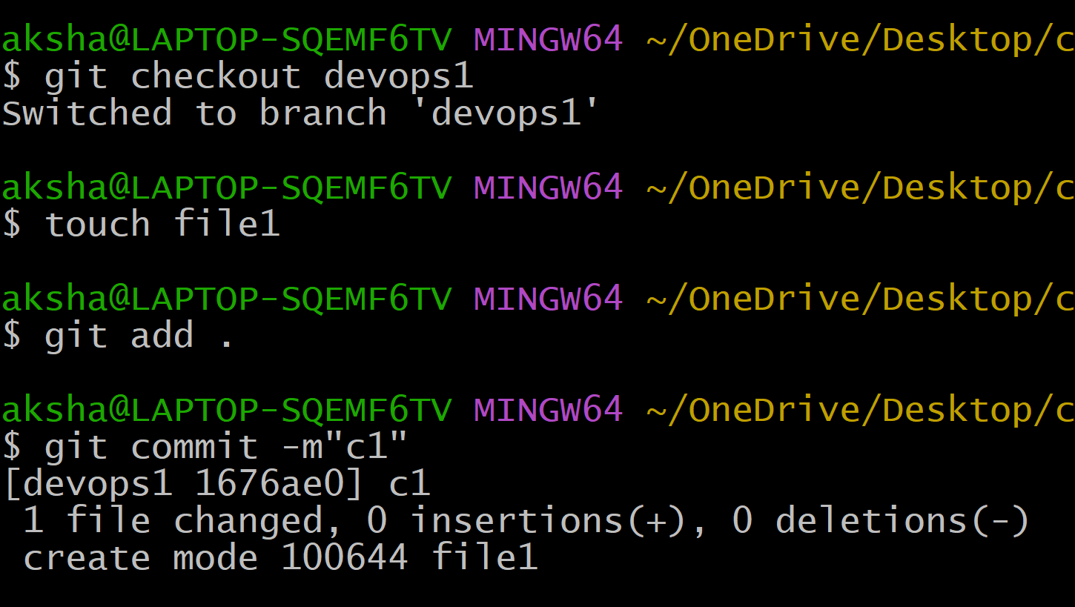

# git push -u origin devops1

(in the pop up appeared put the Personal access token for the token keys)

##########################

You will go to the github repo

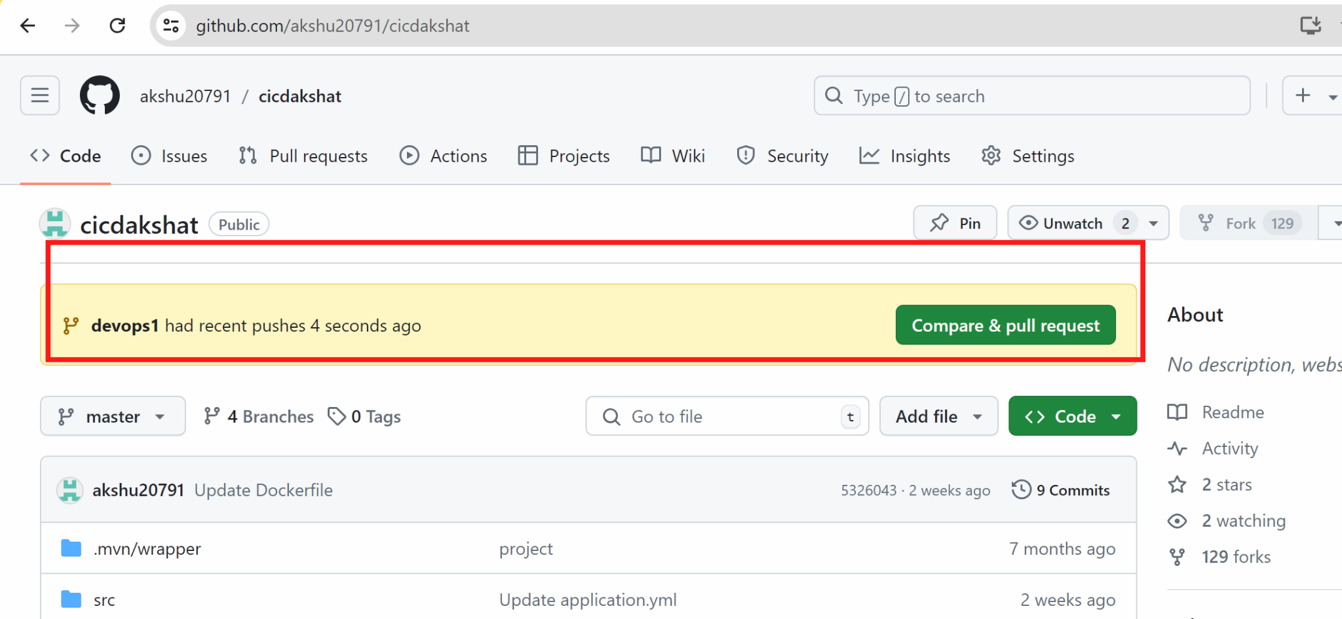

For now we will not raise the pull request…first lets create pipeline

We will open jenkins which we installed in the master

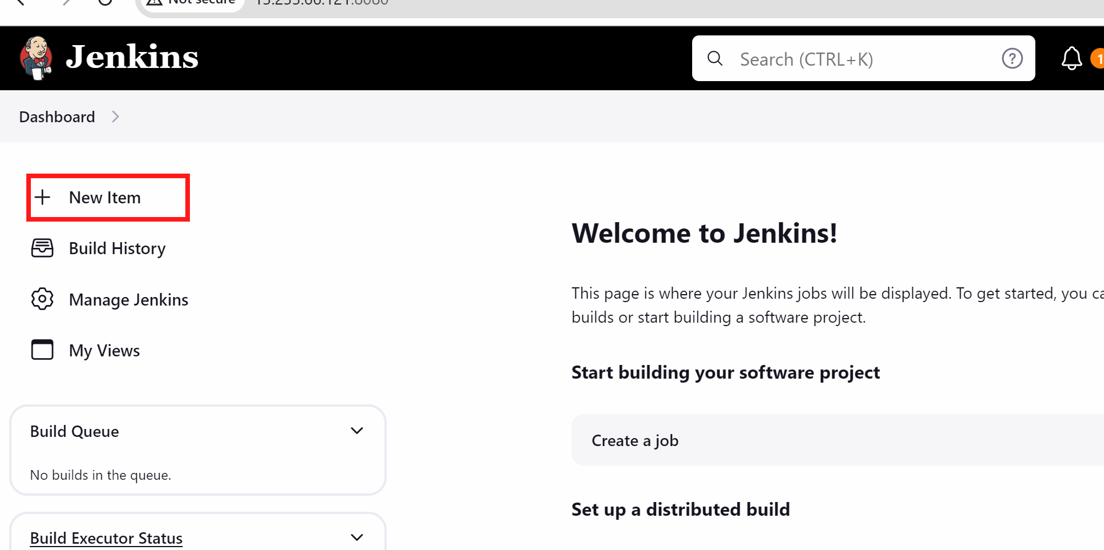

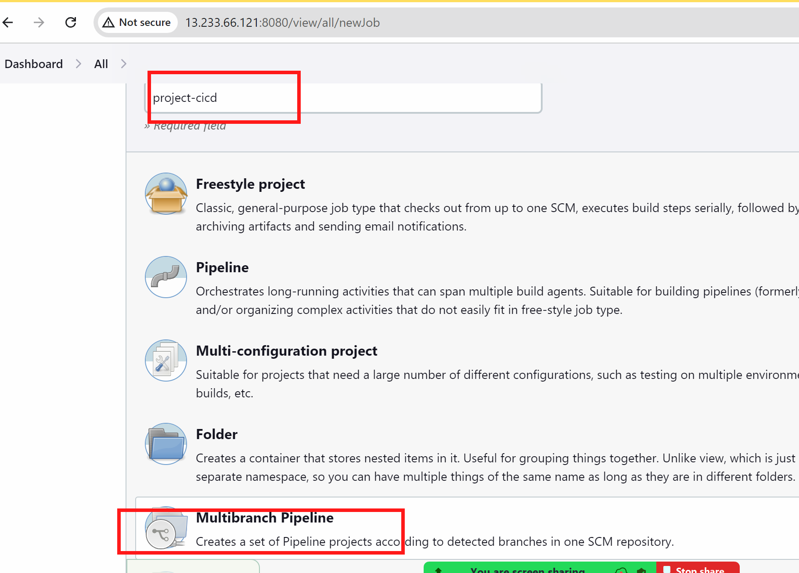

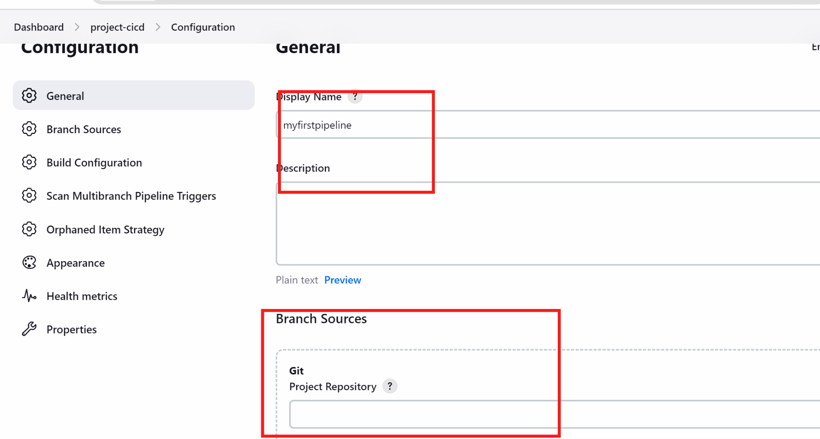

Use source as git

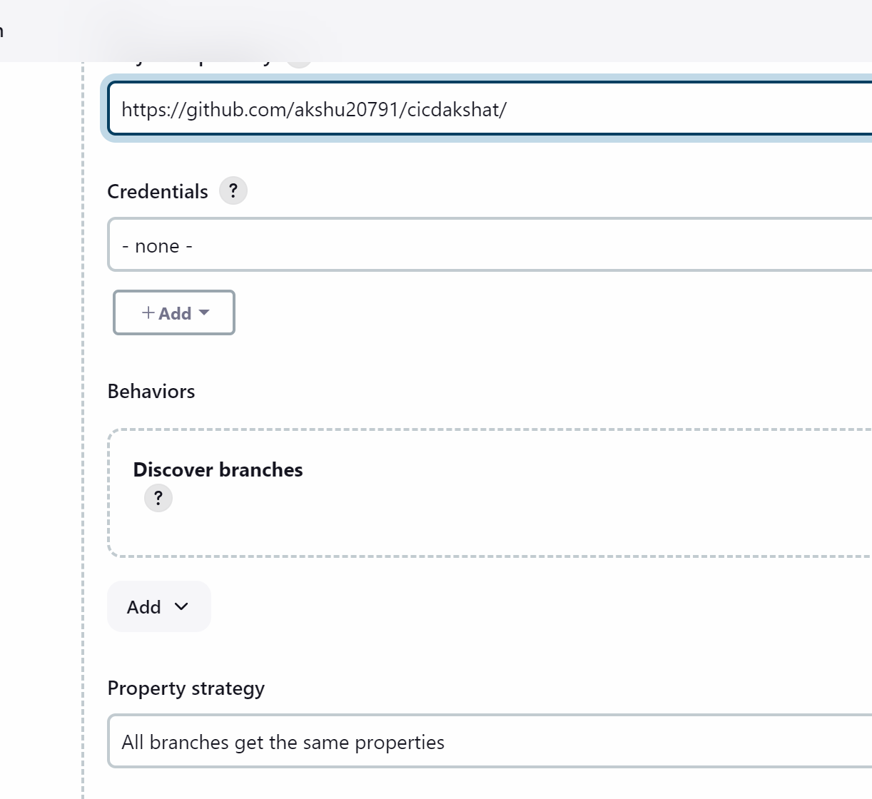

(you can put your forked branch)

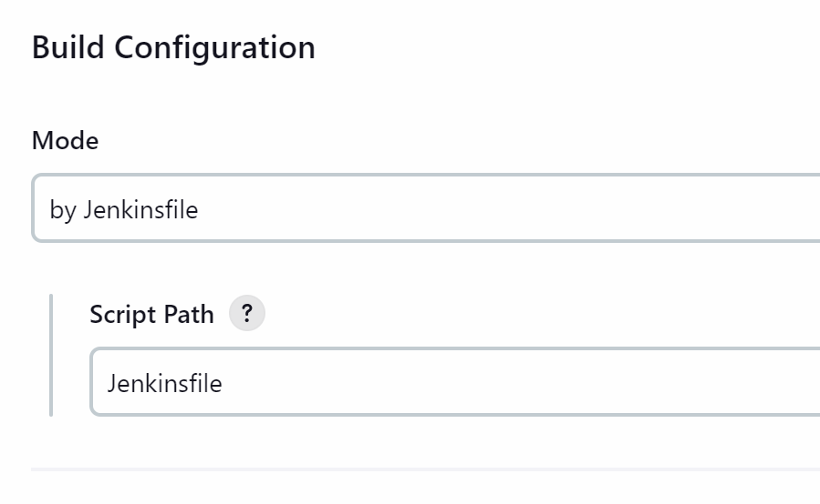

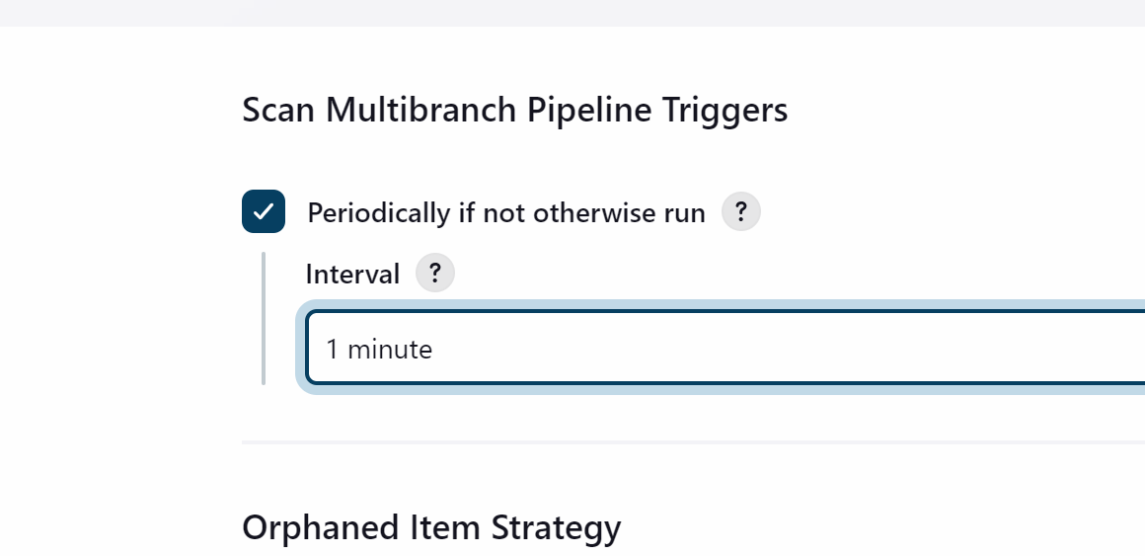

It will periodically check for every 1 min and if there is any update on github then it will build the project

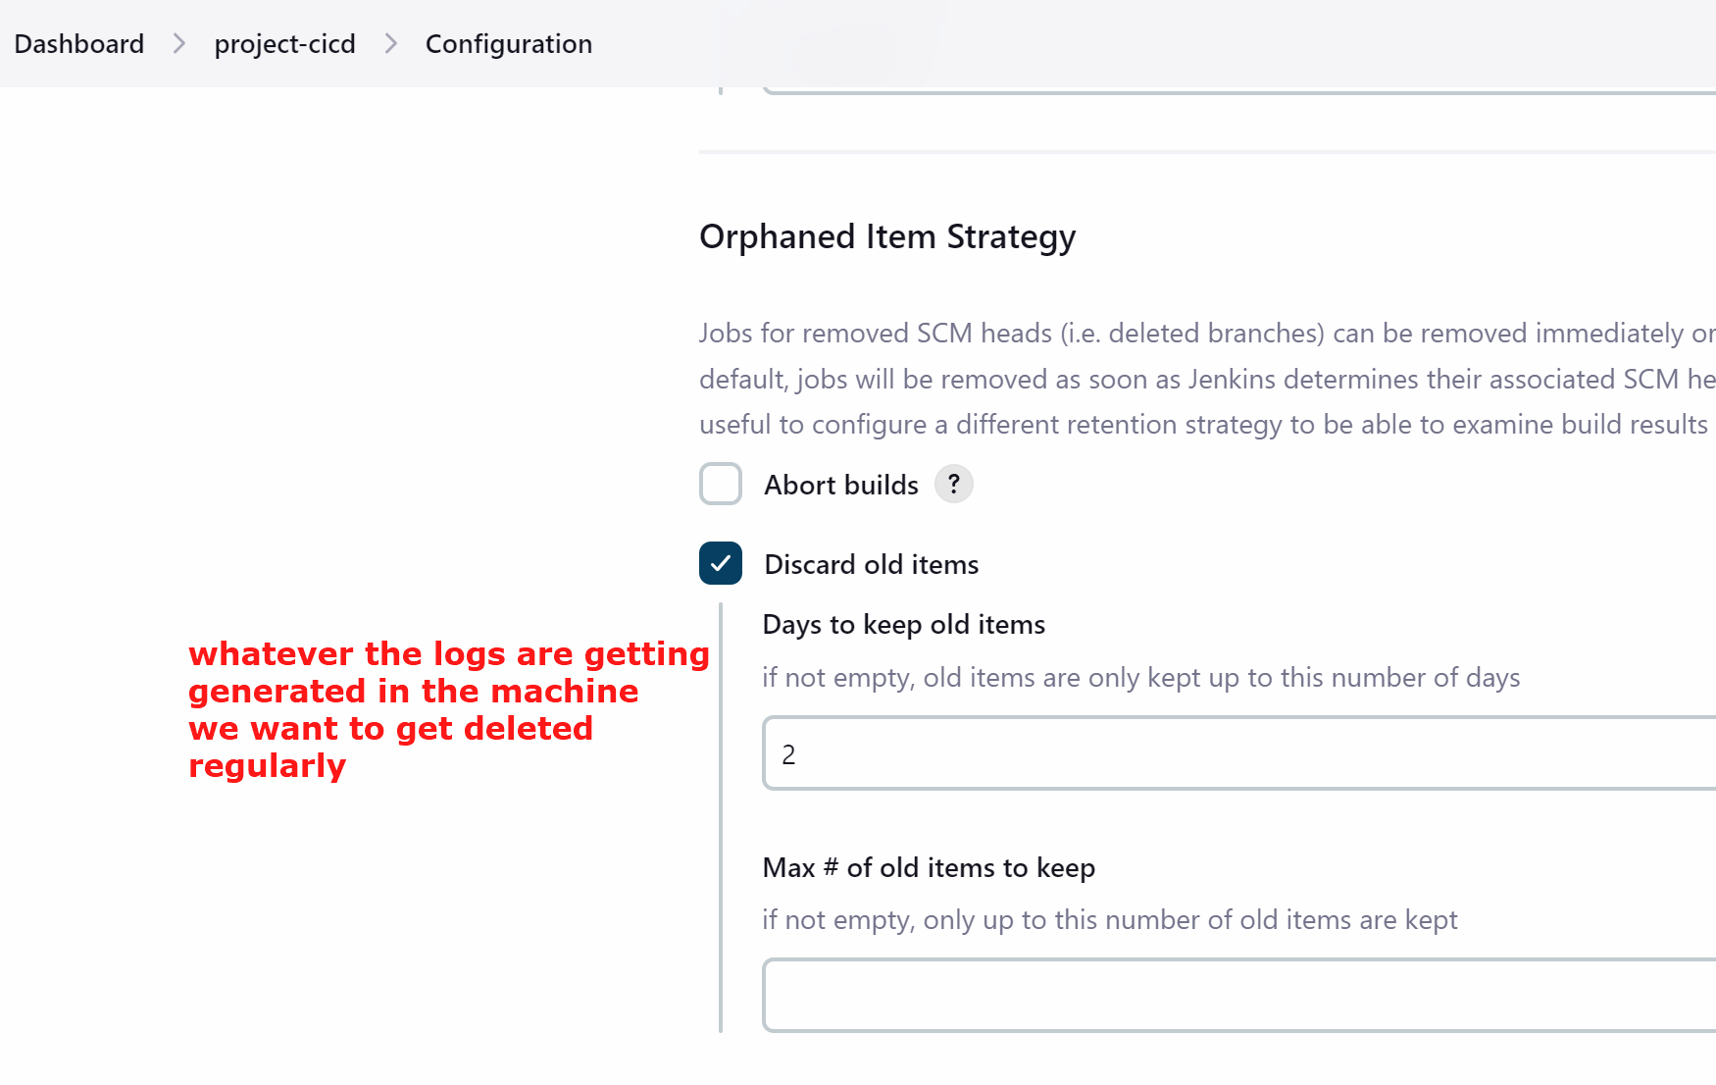

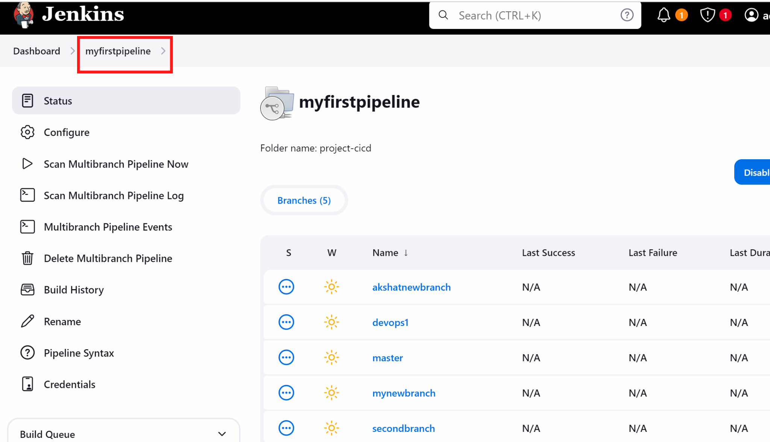

(if builds failed we are fine because we have not configured alot of things as of now)

Go to jenkins dashboard

Go to manage jenkins

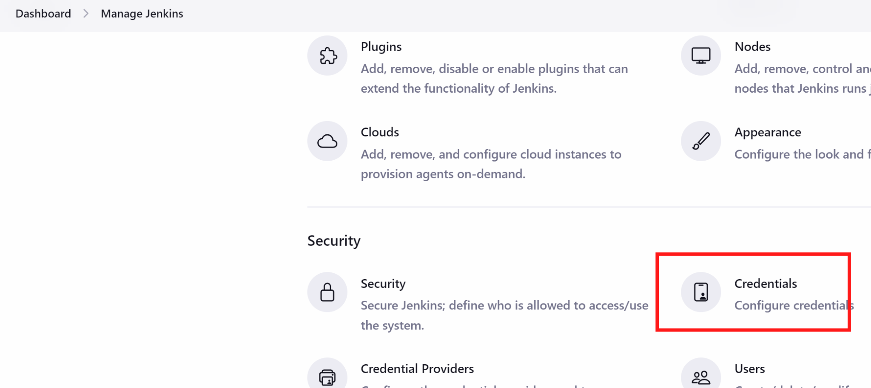

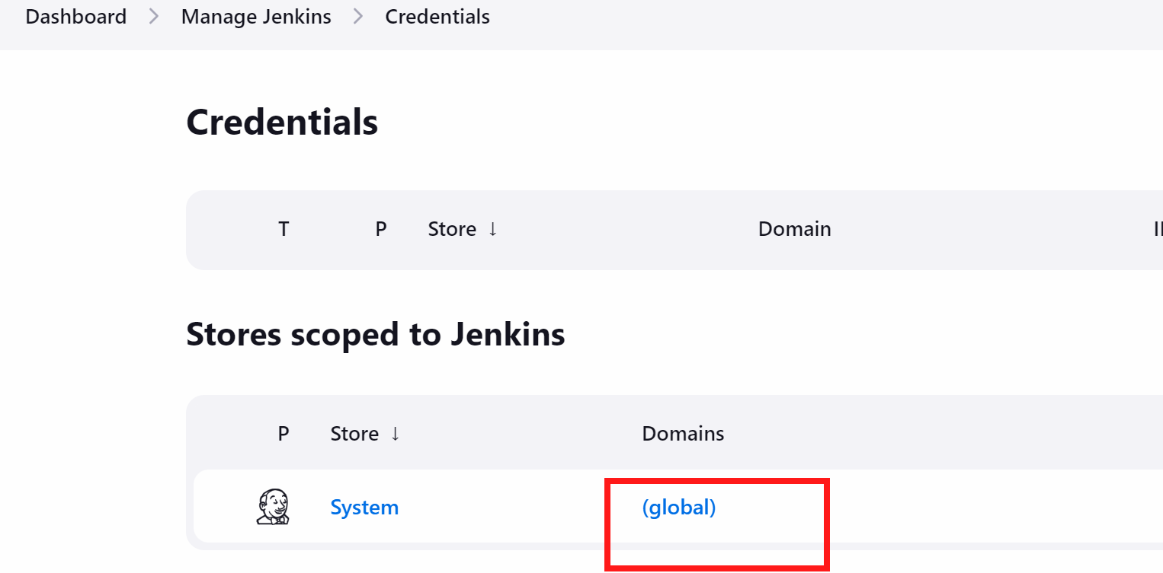

+ Add credential

Here i will be create dockerhub credentials so that my code can be pushed to dockerhub

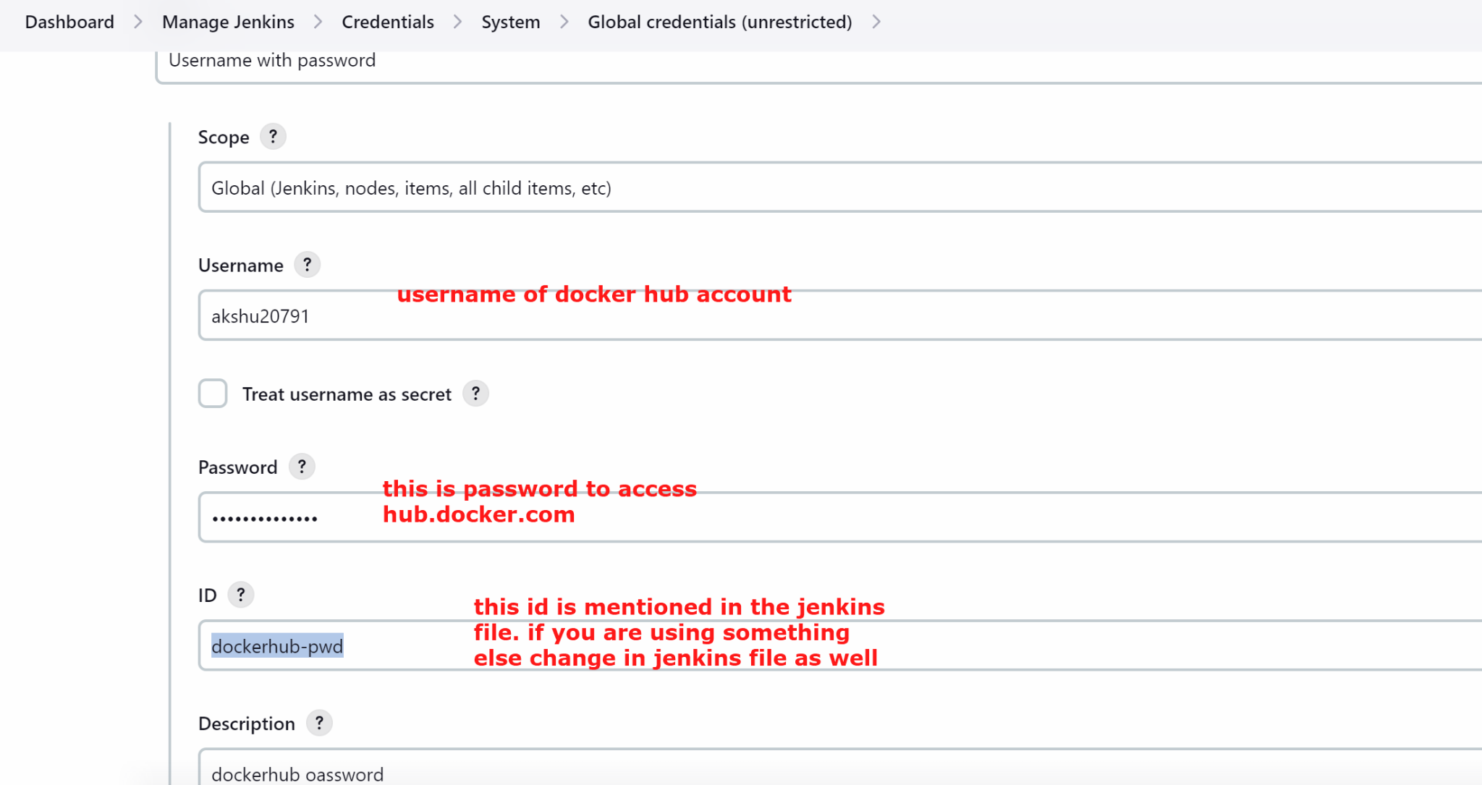

## We will now install some plugins

Go to manage jenkins

We will install docker plugins

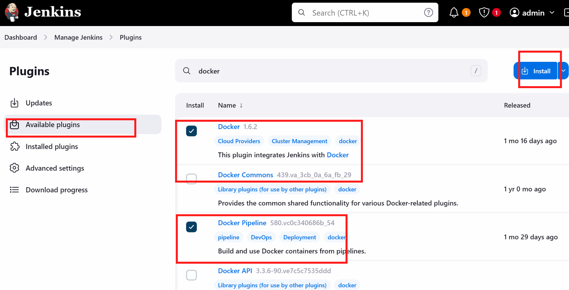

We will also install kubenetes plugin

To install kubernetes plugin 👍 -> we will download a plugin locally from github and upload it on jenkins

Go to https://github.com/akshu20791/cicdakshat/blob/master/kubernetes-cd.hpi

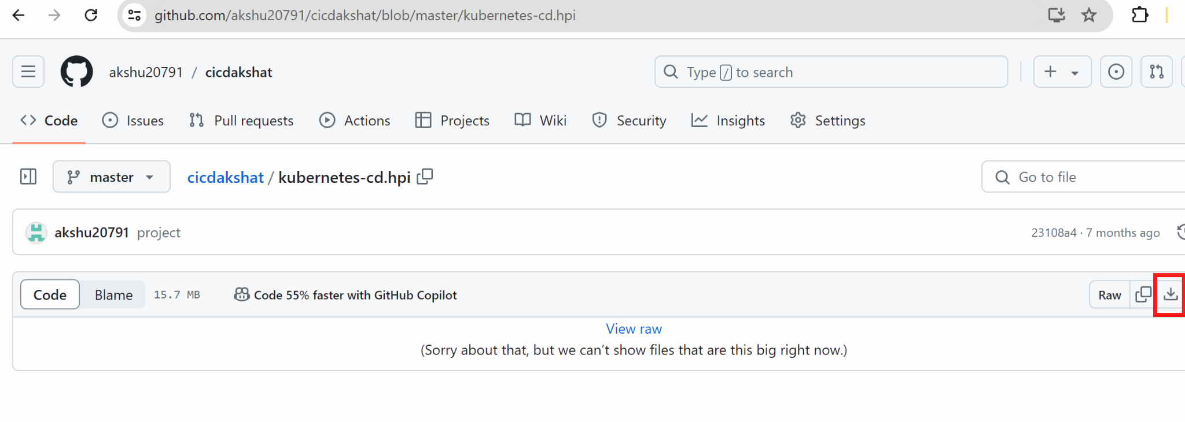

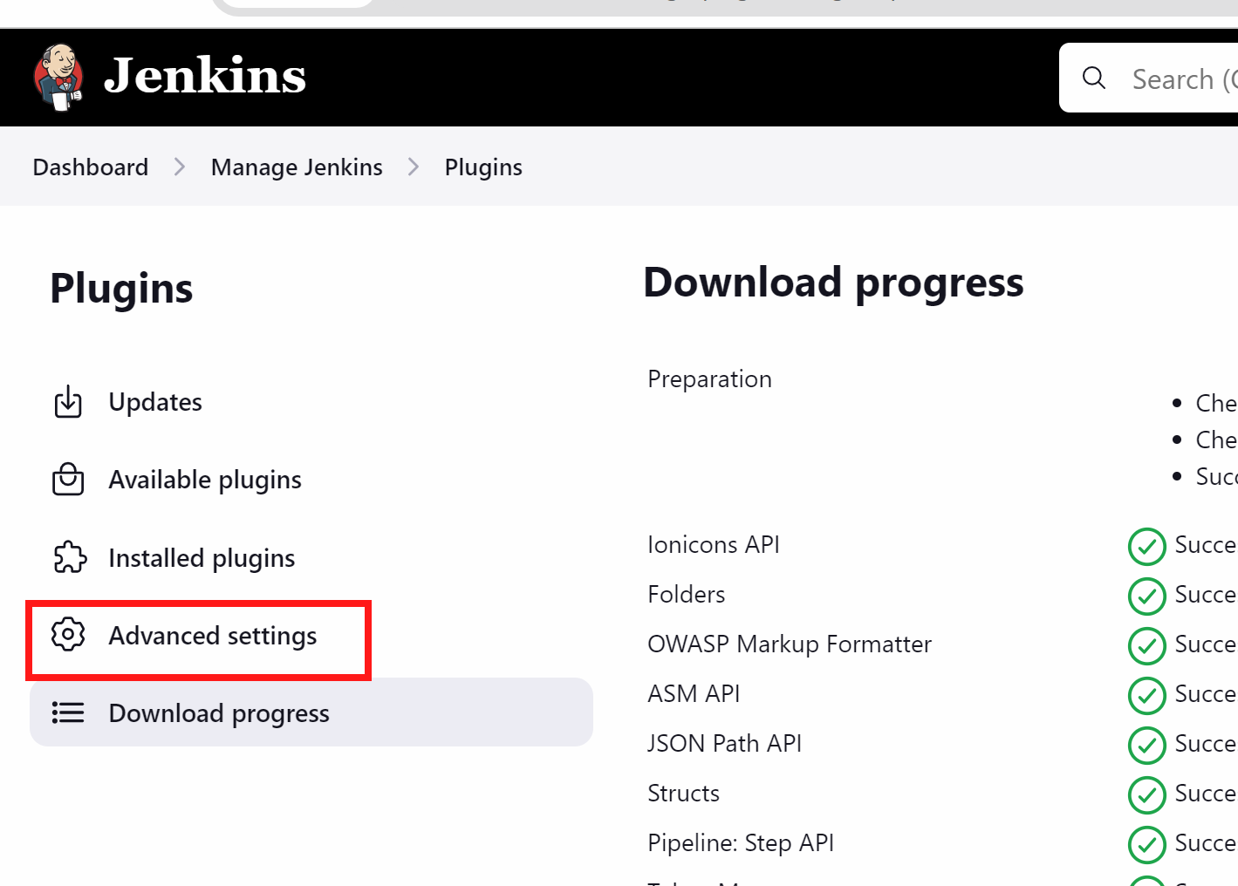

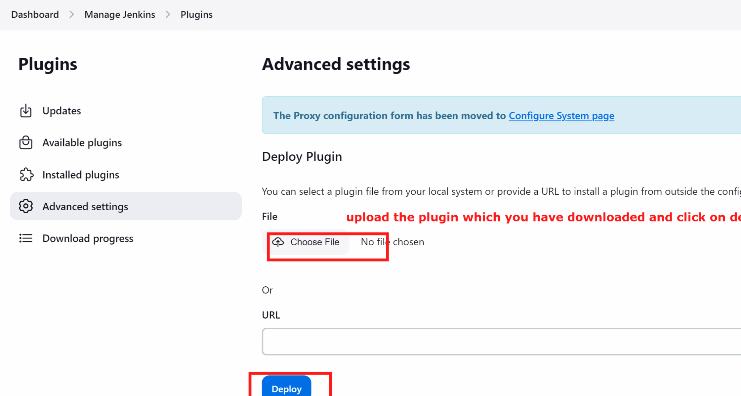

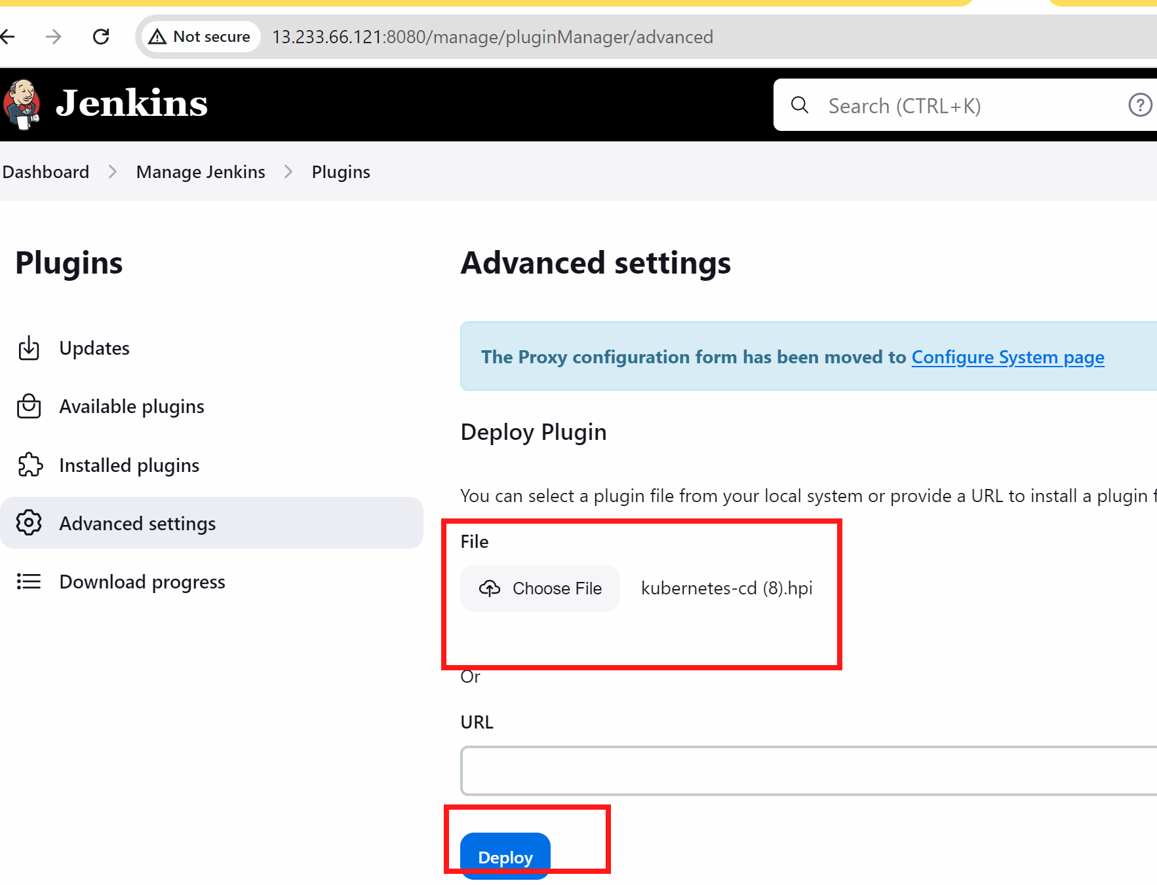

## go to master machine



# service jenkins restart



Now lets once check the jenkinsfile

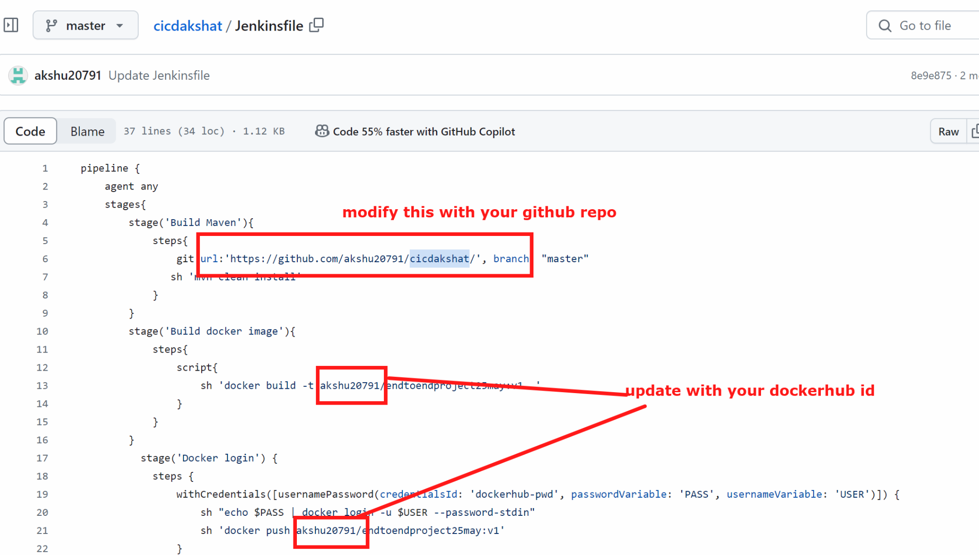

After updating it…we will generate the kubeconfigid

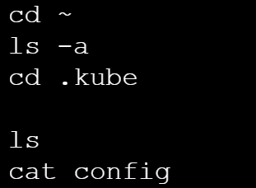

## RUN IN MASTER

cd ~

ls -a

cd .kube

ls

cat config

Copy the whole content which came up

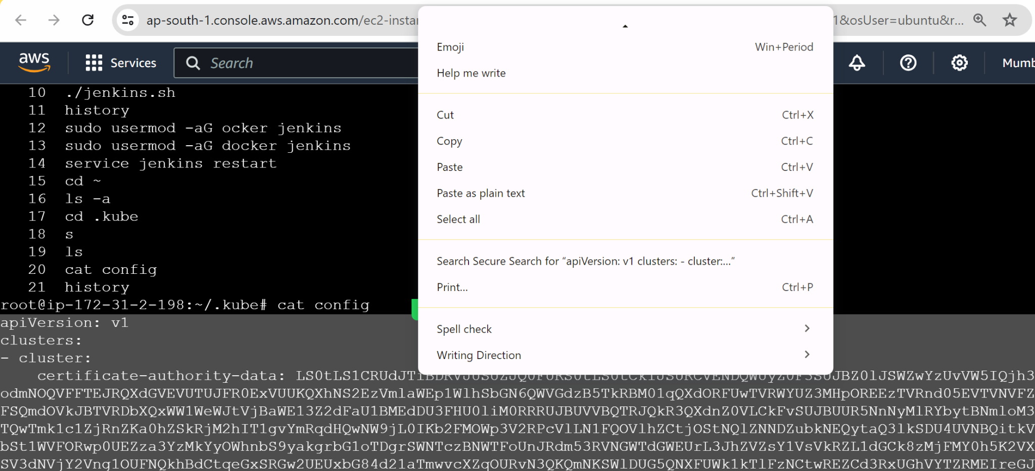

Go to jenkins - manage jenkins - credentials - global

Add credentials

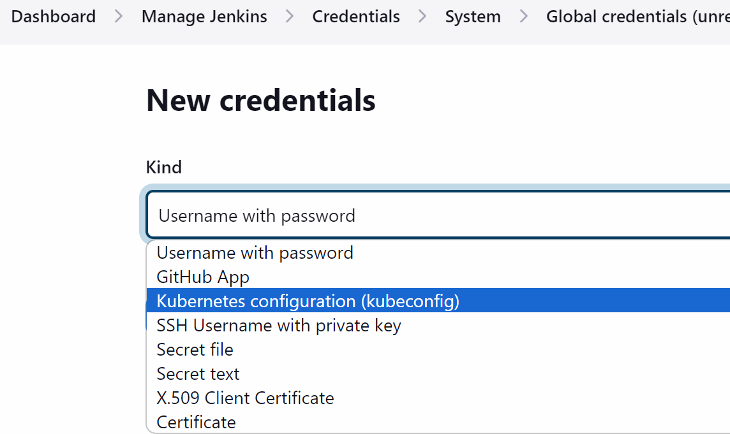

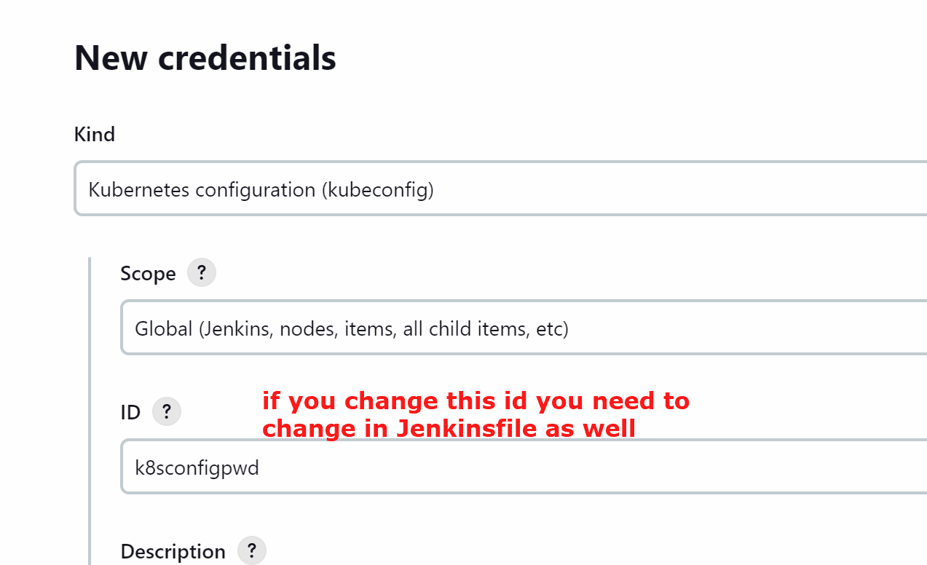

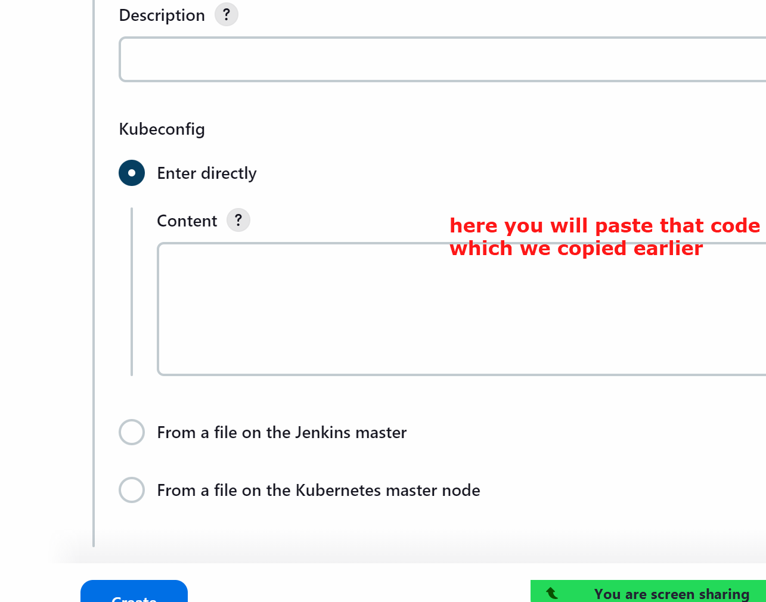

Create

Lets execute the pipeline

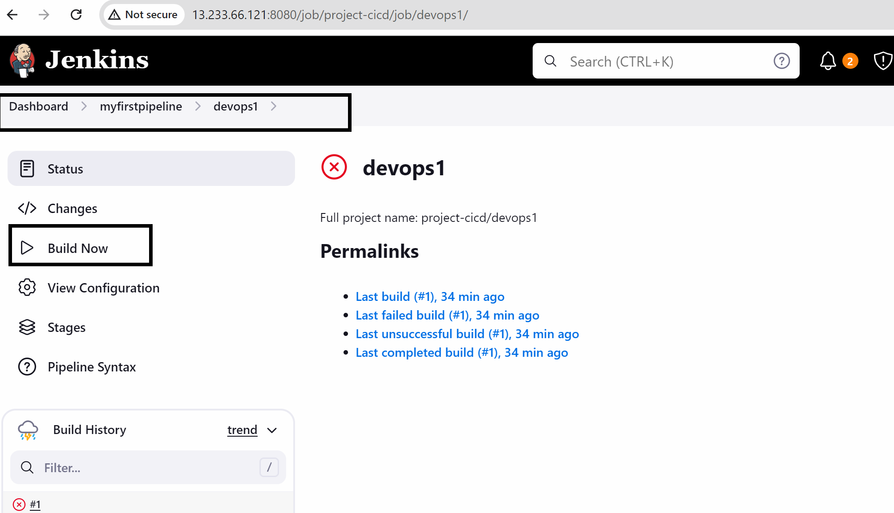

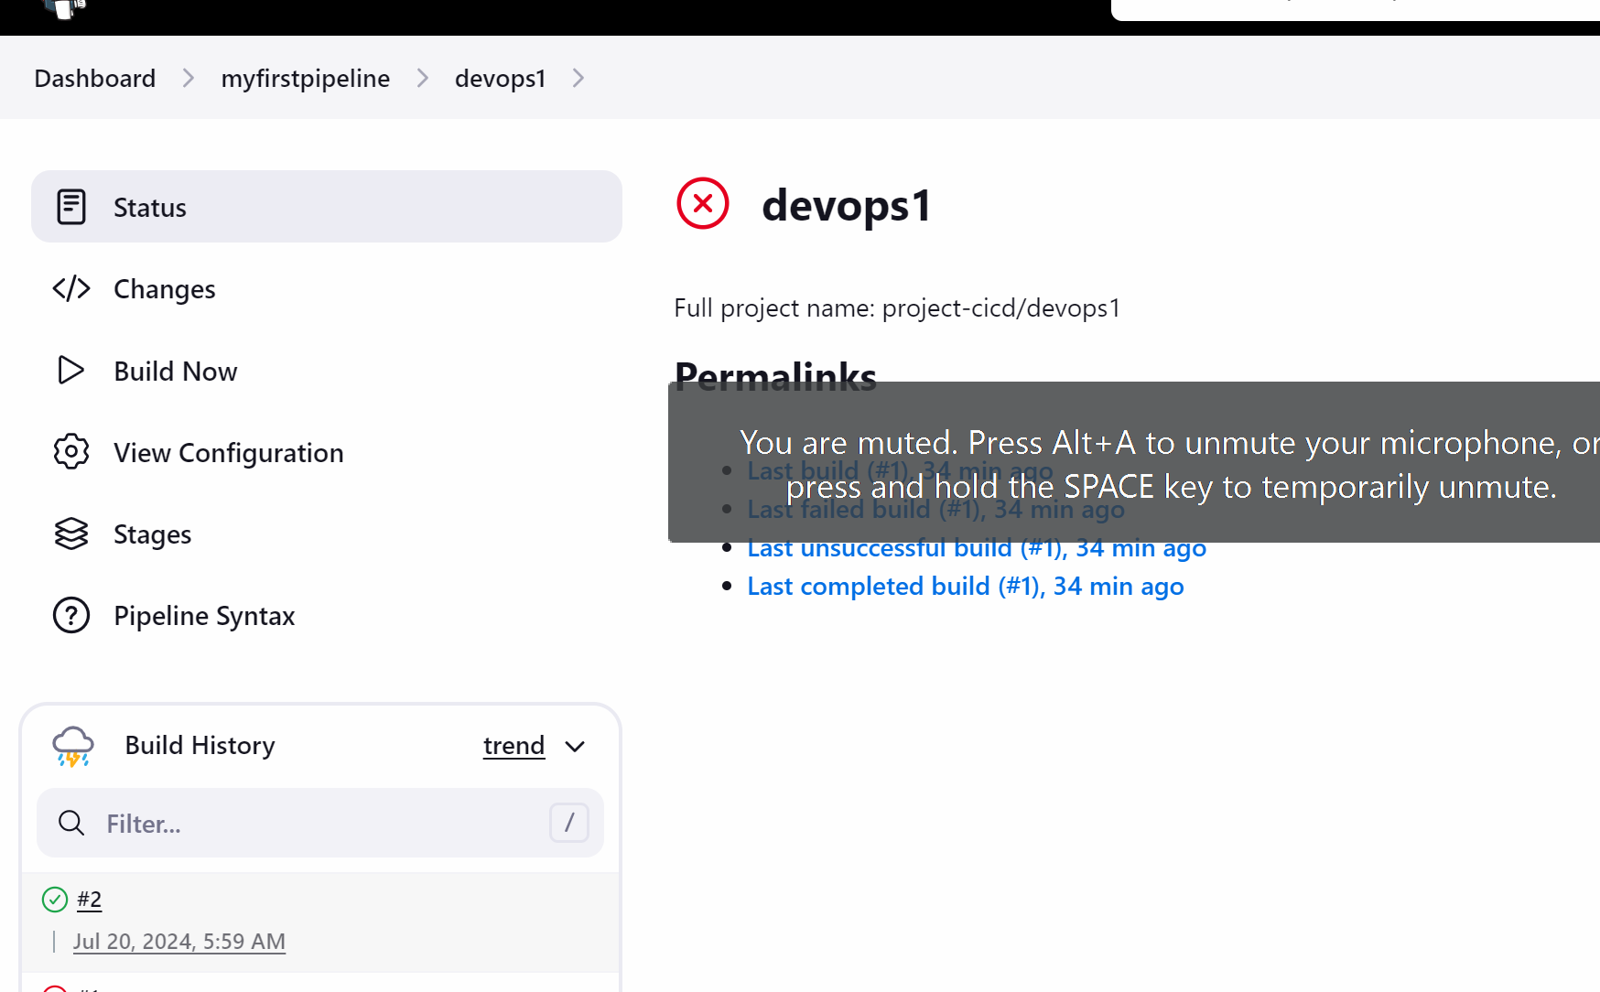

The deployment is not happening in the branch as we have put the condition in the jenkinsfile that if the branch is master then only the deployment will happen

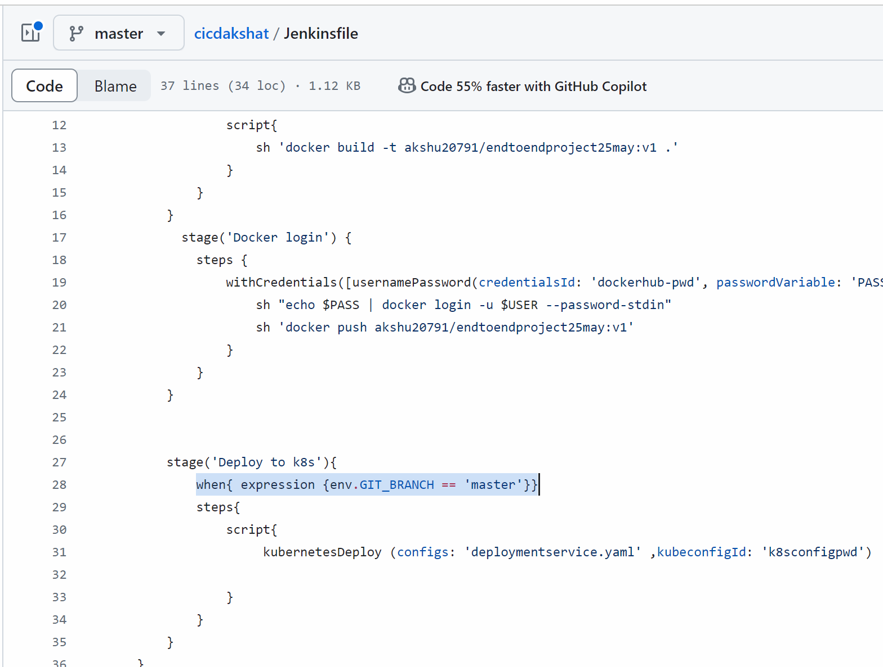

Now developer and manager is confirmed and they wanted to deploy the project…so the developer will not raise the pull request to the manager

Either you can click on pull request rab and raise pull request or

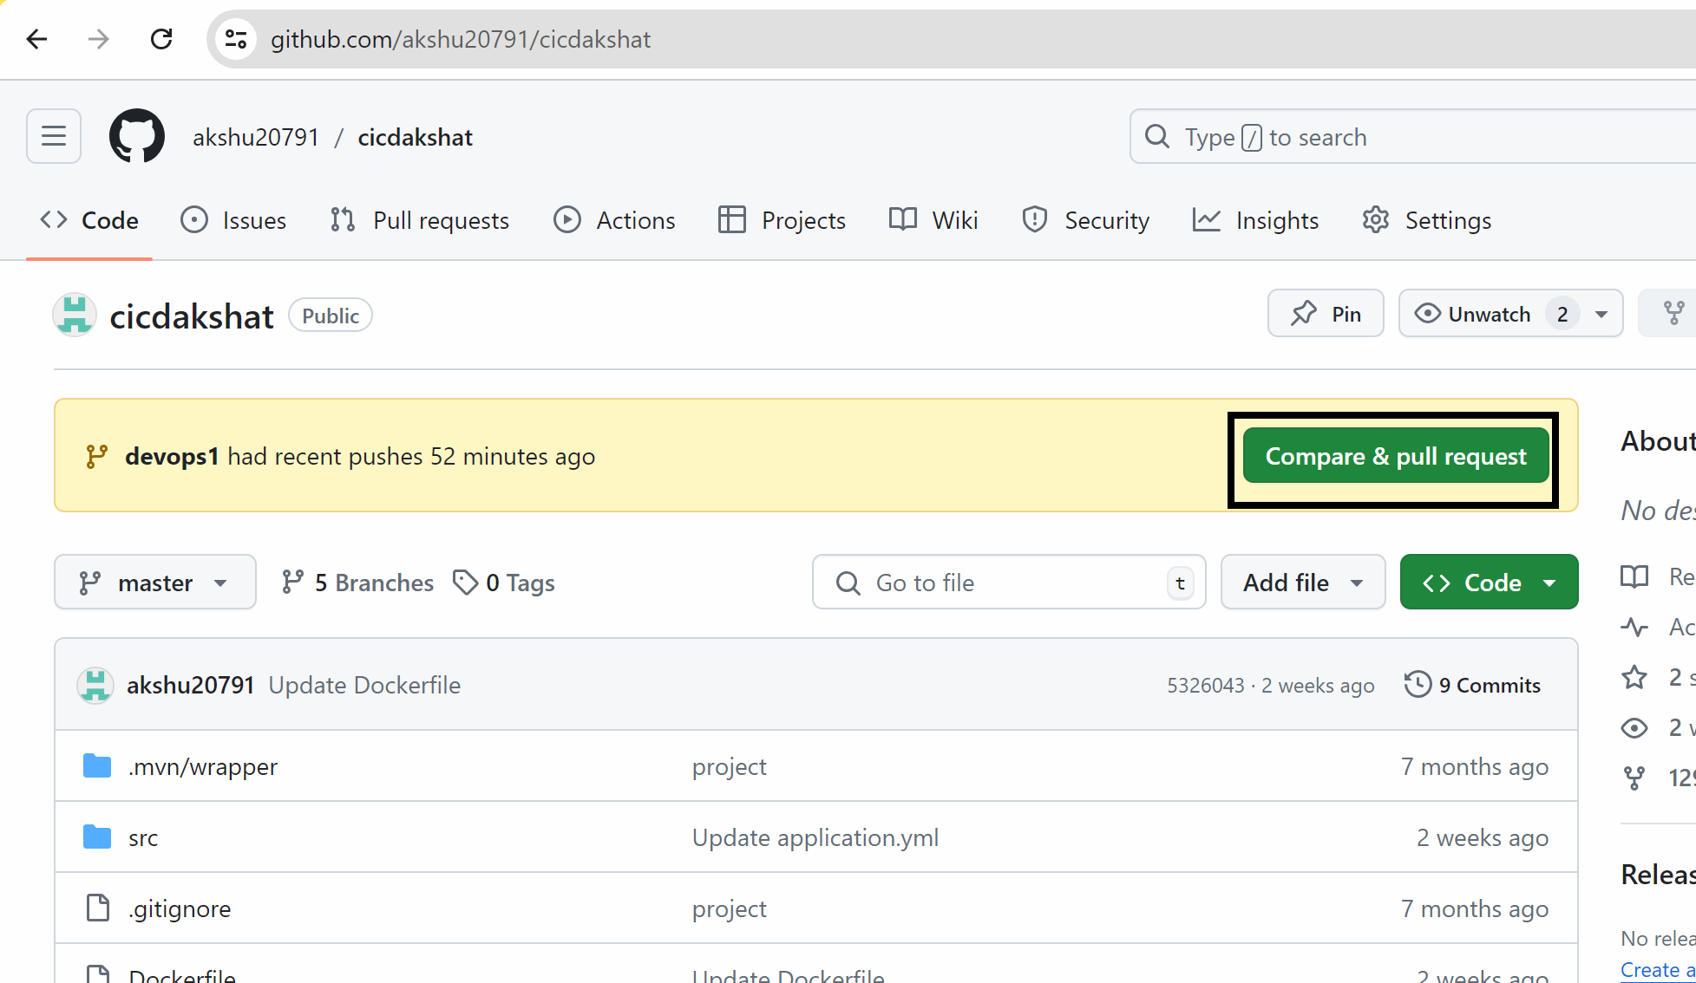

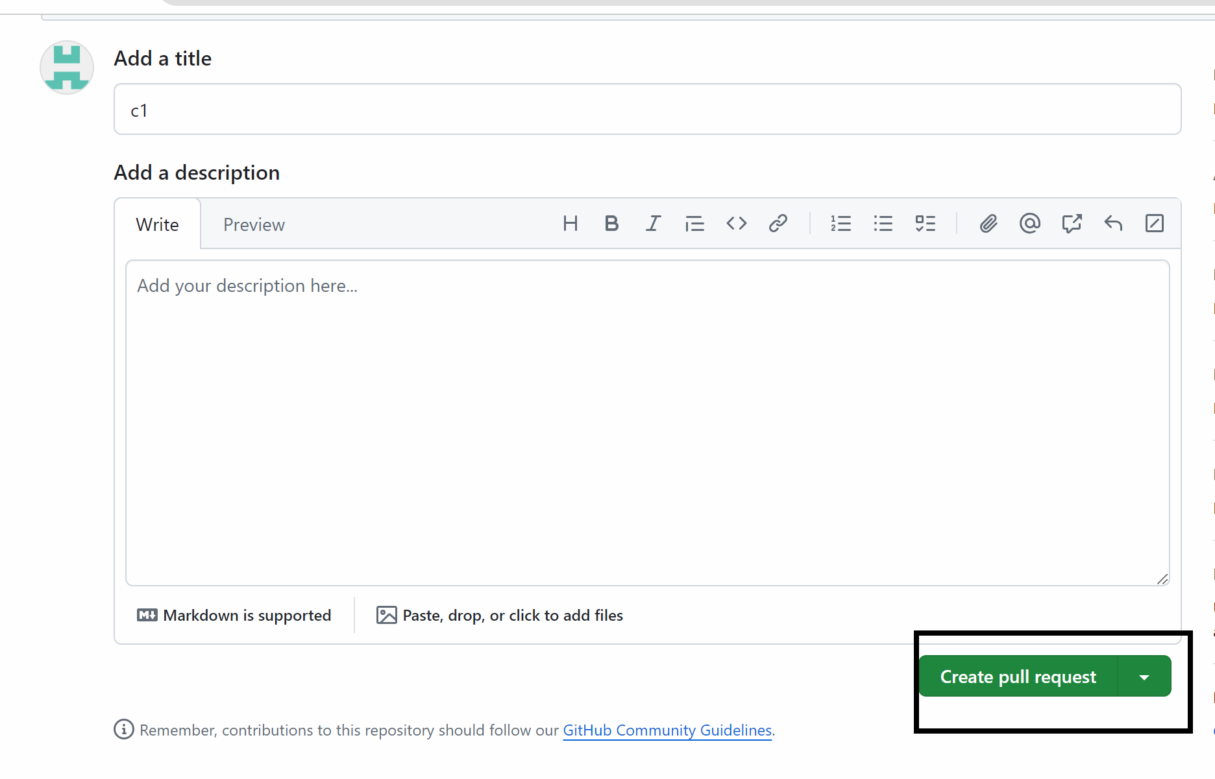

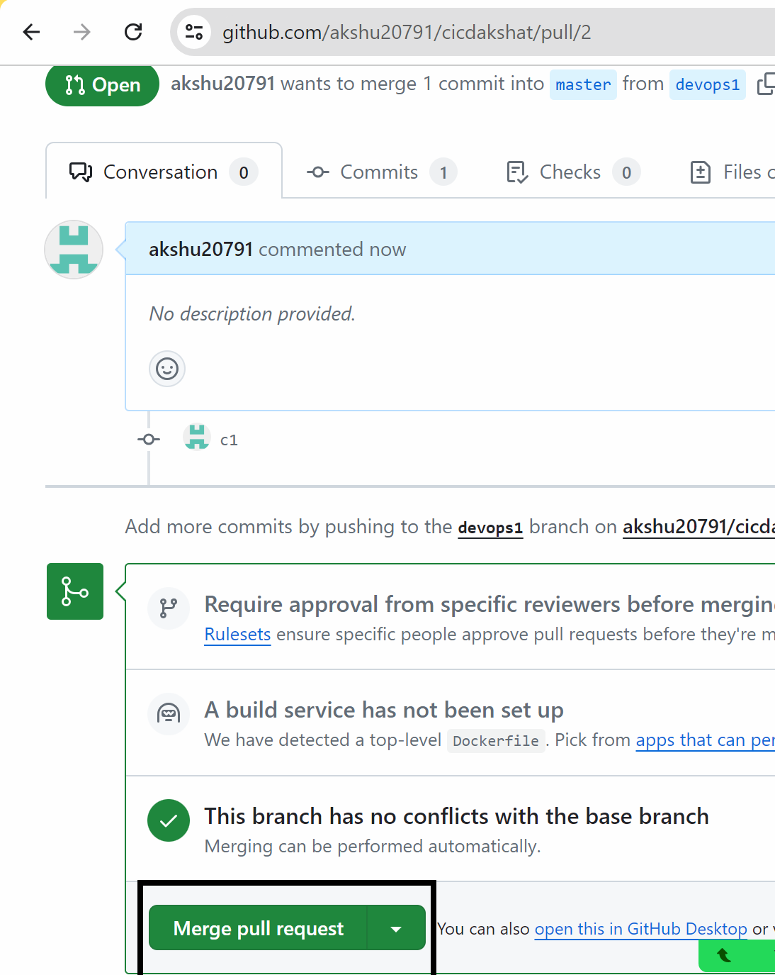

My jenkins pipeline should trigger

My master branch is triggered automatically

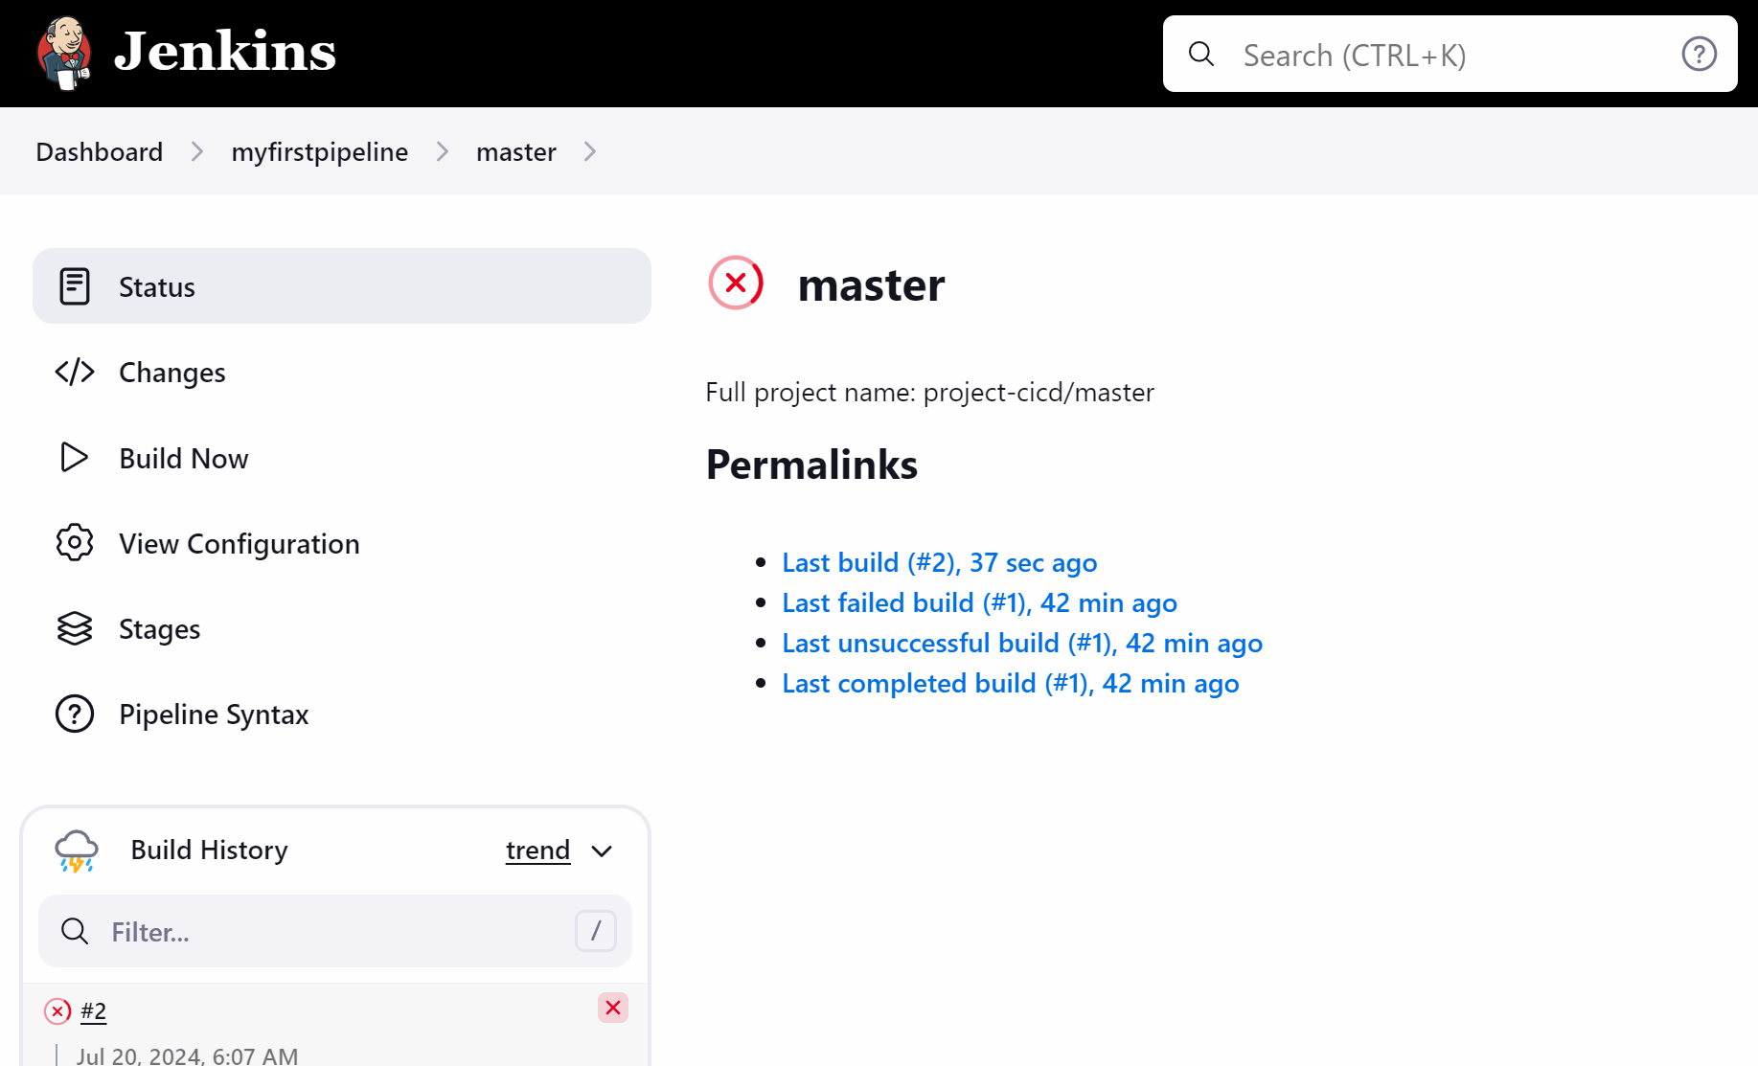

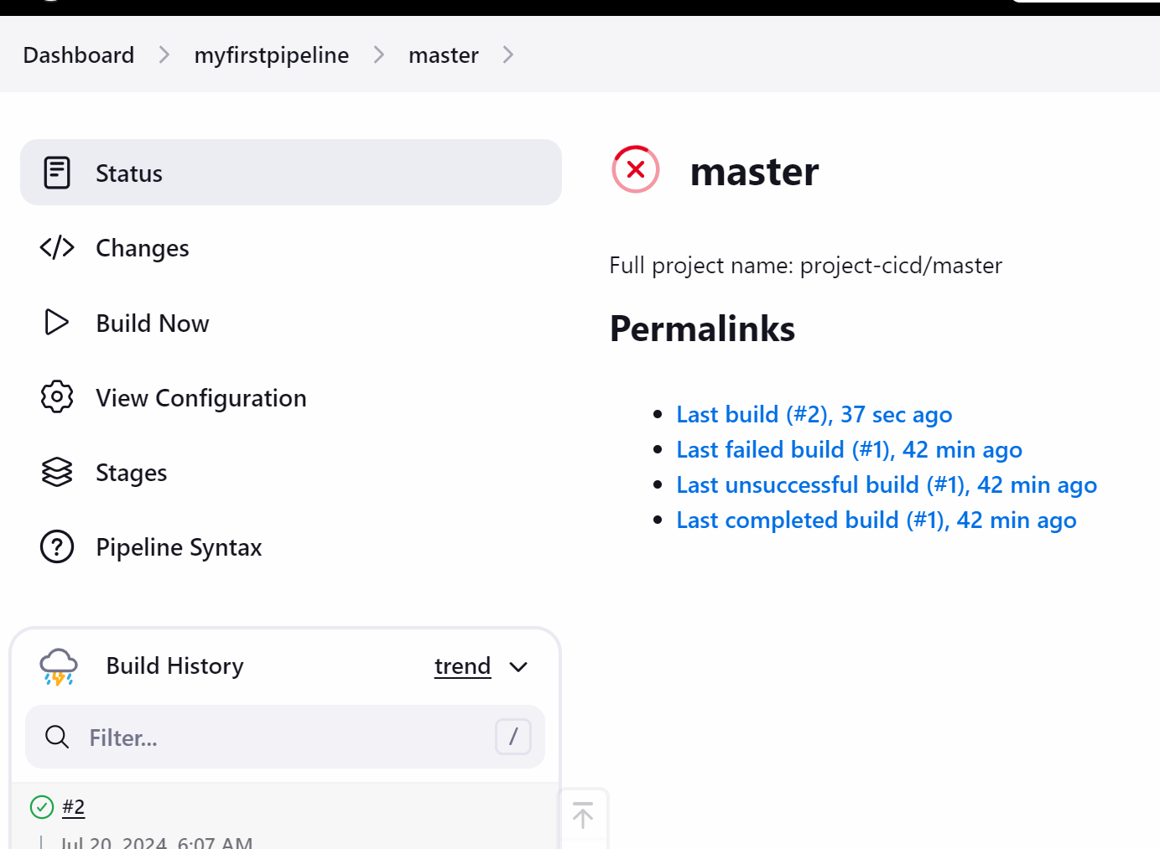

Now lets see how we can access the project

Go to master

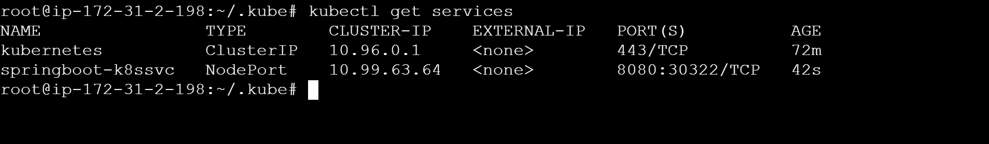

Copy the publi ip of any node :30322

